- A startup is developing an AI-powered healthcare assistant capable of predicting diseases, generating medical reports, and answering patient queries. Create a concept map showing how Artificial Intelligence, Machine Learning, Deep Learning, Generative AI, and Large Language Models (LLMs) are interconnected in this application. Explain the role of each technology.

A.

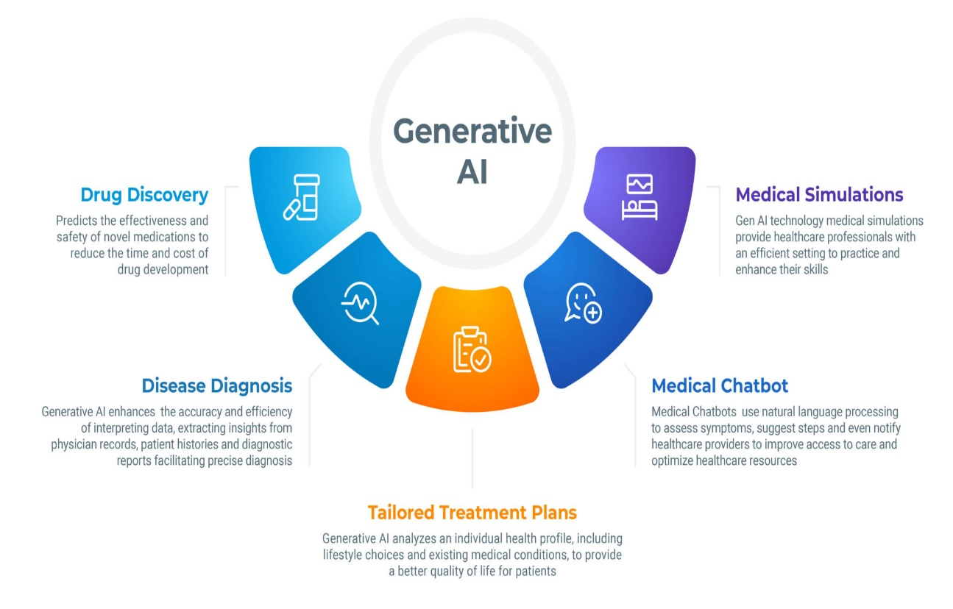

- Create a comparative mind map illustrating the differences among AI, ML, DL, Generative AI, and LLMs based on learning approach, data requirements, computational complexity, outputs, and applications. Recommend the best technology for educational chatbots.
A.
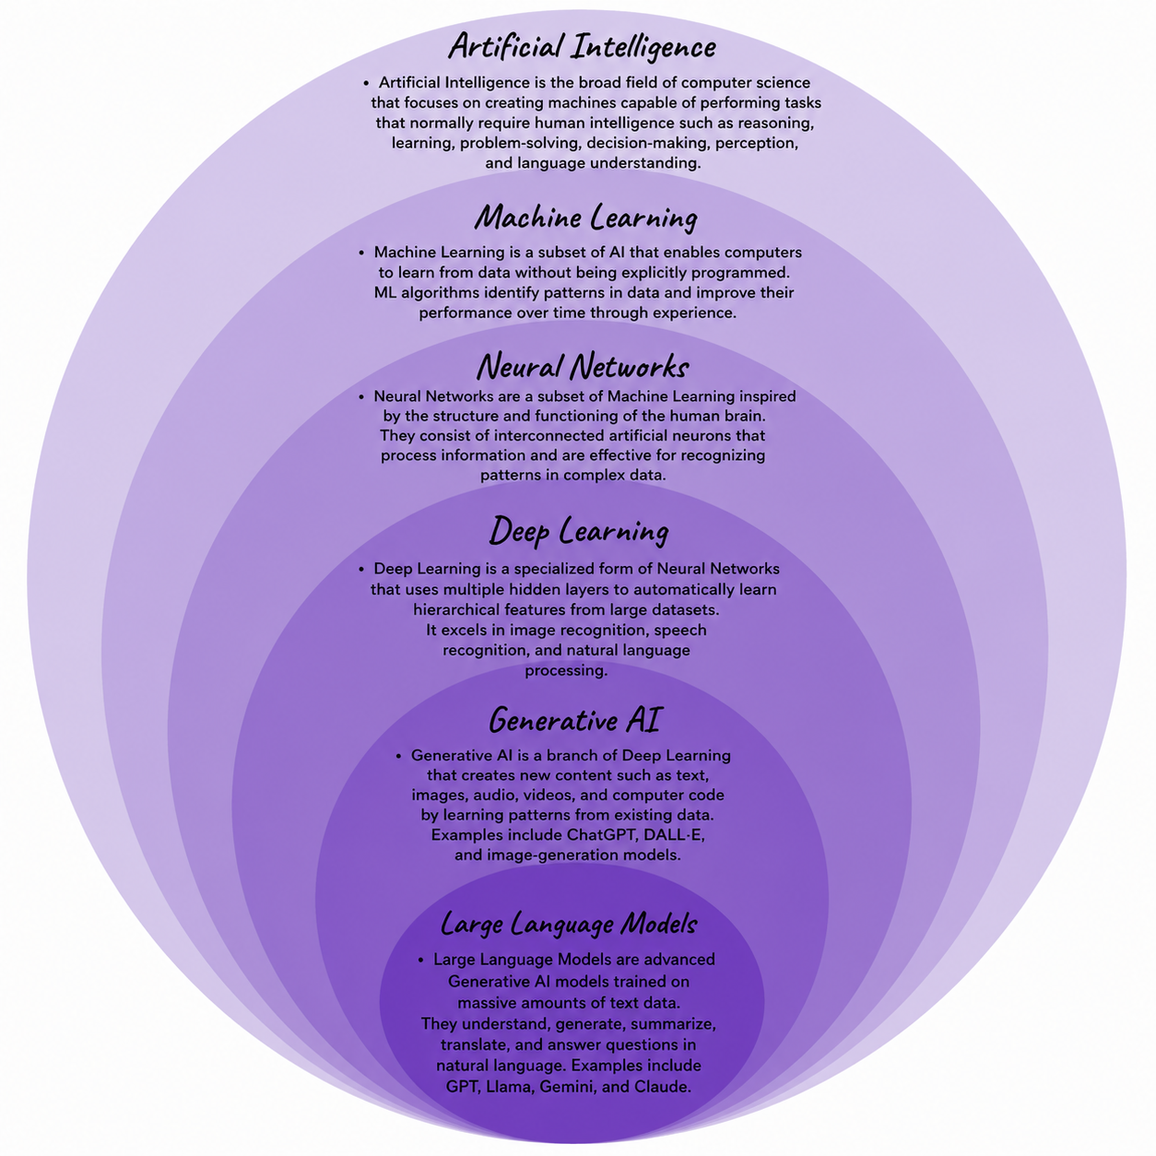
N. Chaitanya Ram
192472172
CSE-AI

